SVFSC Board Meeting
September 11th, 2022
6:30 pm, In Person Club Room Meeting

Officers: Shannon King– President; Erica Olson– Vice President; Amanda Crouse– Treasurer; Sarah Peterson-Secretary
Board Members: Rachelle Klein, Angel Koltes, Miranda Miranowski, Andy Schillinger
Others: Kayla Hammond
Absent: Chanda Muller, Heather Awender

Call to Order @ 6:30pm
Secretary’s Report- Virtually Approved in August

Additions
- Board Membership
- Insurance

Sarah motioned to approve agenda. Angel seconded. Motion carried

Treasurer’s Report:
- Club Account- current balance $15,949.89 – Shannon sent text to Heather to clarify transactions for Headwaters Day supplies

- Trust Account- Current balance $196,489.83 (no changes since last month)

- Gaming Account- Current balance $121,081.44

Miranda motioned to approve treasures report. Andy seconded. Motion carried

Old Business:

- By-Laws-were approved at August meeting and sent to club attorney. Shannon asked the attorney about having them signed. Was told to have signed by secretary. Board agreed only secretary signature is necessary. After signature from Sarah the bylaws will be posted to SFVSC.org and USFSA.org. They will also be emailed to the attorney for our file with them. A signed copy of the new bylaws and the past bylaws will be placed in our minute book and our digital club files.

- Update on Harness exploration- no update

- New Coaches for fall- update It worked well last year to have LTS basic skills group lessons have a lead coach and an assistant. We have 5 (6 if we split Snowplow Sam) groups. In addition to Kayla and Heather, here are the current coaches for fall 2022:
        - Yes, to coaching Sunday’s 2022-2023 – Kelsey, Laura Formaneck, Katie Rauber
        - Yes, to Subbing 2022-2023 – Maegan Bellmore, Katie Tschakert
        - Yes, to Jr coaching 2022-2023 – Autumn, Paige, Jaidyn
        - Yes, to Jr Dance coaching 2022-2023 – Makenna (Saturday, Sunday, or possibly both)
        - Waiting to hear from Abby
        - Erica Olson is also willing to coach or sub as needed for 2022-2023
        - Potential senior skater from Fergus Falls

- Headwaters Day Informational booth: Went well. Heather passed out snow cones, tattoos, and fliers

- Registered for NDSCS Homecoming parade. Jess has some seeds and is getting more. A family has already reached out about donating candy.

- Early Fall Ice registration is up and running and information has been shared with the club and Fergus Falls
- Fall Merchandise
- Clothing -Link and page are being set-up by Rambow
- Yard Signs-Miranda connected with the state gaming department about advertising. We are able to transfer funds from our gaming account into general account and use that money for advertising. However, once the money is moved to the general account it needs to stay there. So executive board approved having Heather order 50 12x18 and 5 18x24 yard signs. Once Heather knows the total purchase price, Miranda will transfer funds from gaming account to regular club account. Quantity decision made by the Executive Board.
- Fall Session Registration is set-up in Go Motion and can be viewed by those with administrator access. Please review and let Ginger know of anything that needs changes. In person Registration Days/Times are:
- Try Skating for Free Day- 6:00-7:30 pm Sunday, October 9 (board meeting) – Shannon and Amanda willing to work
- 1st night of skating –4:30-6:45 pm Sunday, October 1- Shannon and Amanda willing to work
- Compensation Committee Updates-
        - Via survey to the full board-Committee proposed
  - 5 hours per month for incidental club work for Kayla, Heather, Bookkeeper and Marketing and Communications
  - $60 per day per diem when representing Client at competition or testing
  - Both items were approved via the survey on August 31, 2022.
        - On August 31, 2022, via survey the board approved sending the contracts to our club attorney for review and sharing the draft contracts with our service providers.
        - Contracts and compensation worksheets were updated with changes approved at August meeting and the changes approved via e-mail since the August meeting.
        - Draft contracts we shared via email with Kayla Hammond, Heather Awender, Miranda Miranowski, and Ginger Schillinger and in print format with Katie Rauber. Their 2022-2023 compensation rate began September 1.
        - Contracts were sent to the attorney for review. Once the legal review process is completed, we will collect signed contracts.
- Advanced Spring Show Requirements were approved via e-mail on August 29, 2022.

New Business:
- Skater Spotlights/Coach spotlight – Discussion held to skater spotlight of each group lesson and do spin off of the previous advance skater spotlight for the coaches

- Advanced Photos- Discussion held to have advanced photos in the falls so there are not advance photos and show photos taken so close together. Shannon will contact photographers. Angel will collaborate with hockey regarding senior posters.

- COVID Policy 2022-2023 – Discussion held to leave as is

- Board membership- USFSA information

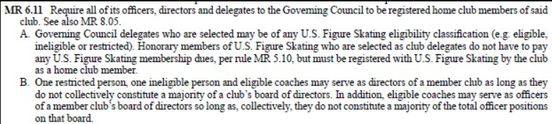
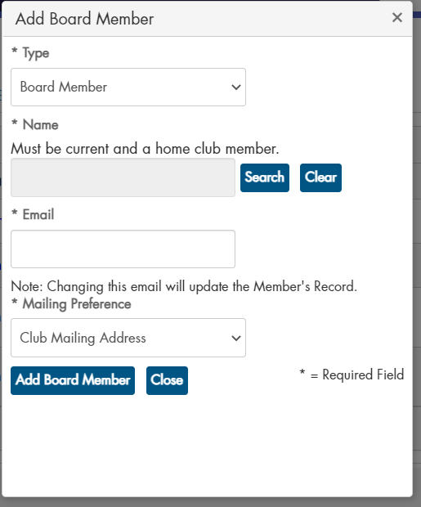

Kayla is making sure each board member is registered.

- Skate Safe (Safe Sport)-Status
  - Sara Peterson – 11/23/2022
  - Shannon King – 11/28/2022
  - Ginger Schillinger – 1/29/2023
  - Miranda Miranowski – 2/3/2023
  - Erica Olson – 2/7/2023
  - Angel Koltes -2/13/2023
  - Chandra Muller – 3/12/2023
  - Amanda Crouse – Please complete once USFA Membership is paid with club memberships
  - Rachelle Klein - Please complete once USFA Membership is paid with club memberships
  - Andy Schillinger - Please complete once USFA Membership is paid with club memberships

Kayla currently serves as our safe skate chairperson.

- QuickBooks. Sarah motioned to purchase 1 year subscription to quicks for $160/year. Angel seconded. Motion carried.

- Website Information –
  - Command Buttons for LTS and Advanced Pages currently give 404 error as content is gone. Discussion held to have Ginger update information for both LTS and Advance with basic information. Kayla will send Ginger previous information that was on website
  - Discussion held to add a command button for Newcomers
  - Discussion held to add FAQ or Q&A page

- Club Sponsorship Opportunities/Levels – Ginger has previous letter used. Discussion held to have her update letter and send to potential sponsors.

- Welcome Information
  - Welcome Back Letter – Shannon will update last year’s newsletter
  - Parent Meeting – 6:00 pm, October 23
  - Parent Handbook – Shannon complying information and will ask board to edit

- Board presence at LTS, Table Talks, or some other format – Discussion held to not hold tablet talks this year due to lack of participation from parents/skaters last year and increase presence of coaches this year.

- Volunteer and Fundraising

  - Clarification was made that volunteer requirements are for all families
  - Amanda motioned to waive fundraising requirements for new families for the first session of skating. Miranda seconded. Motion carried.
  - Discussion held to invoice families that did not meet volunteer requirements

- Fall Volunteer Opportunities
  - Headwaters Booth-already completed
  - NDSCS Homecoming Parade (donate candy, participate, label seeds)
  - Weekly cleaning of club room
  - Ice Monitor for every block
  - Music player for every block
  - Skate Room Sunday nights
  - Holiday Show
  - Club Committees
  - Attend Board Meetings
  - Others TBD

- Club Committees/Coordinators
  - Current Committees
    - Costume Committee – Chair and two other members. Role has already been defined by board.
    - Concessions Committee – currently a Chair propose adding at least one other person. Plans concessions for Holiday Show, Spring Show, and Leap and Compete. Proposes plan and prices to board for approval. Works with Volunteer Coordinator to post needed items in Go Motion.
    - Compensation Committee – currently four people, propose making this a standing committee with at least two of the members being current board members. Evaluates compensation rates in February/March to propose any changes for the next year to the full board at April Board meeting. Goal to have contracts written and signed in May before the new fiscal year.
  - Propose revitalizing the following committees with the following structures
    - Decorating Committee-2 to 4 people, any club members; plans and executes decorations for Holiday Show, Leap and Compete, Spring Show (on ice, off ice, lobby, concessions, awards area, locker rooms, etc.); board would approve the budget per event and final set choice for the ice show. Works with volunteer coordinator to post decorating volunteer opportunities in GoMotion.
    - Fundraising Committee- Current treasurer and two other individuals, any club member; plans and proposes fundraisers to the full board then executes board approved club fundraisers. Works with volunteer coordinator to post fundraising volunteer opportunities in GoMotion.
  - Propose New committees
    - Bylaws Committee – Annual review of the bylaws. All board members review and update together or the exec team reviews and proposes updates to full board
    - Competition Committee – Chair and two to three others, could all be club members
      - Leap and Compete-help Heather with items as needed, help the day of, set-up check-in area, set-up dress sale area, set-up judges scoring area, set-up announcing booth, organize flowers, organize teas, vendors (if applicable), help decide gift bags, etc. Works with volunteer coordinator to Leap and Compete volunteer opportunities in GoMotion.
      - Out of town competitions-Arrange hotel blocks for out of town competitions, Team Building supper/pool time one night, sharing skate times of club members (or at least the original ones).
  - Coordinators
    - Volunteer Coordinator- Works with Marketing and Communications Specialist to post volunteer opportunities in GoMotion, promotes volunteer opportunities, works to fill unfilled volunteer spots especially for key roles for main club events
    - Daily News liaison-Collects club news information from coaches and shares with the Daily News
    - Room Block Coordinator-Arranges Room Blocks for out-of-town competitions, if this is not a role of the competition committee

Shannon will send sign-up genius to entire club after parent meeting on October 23.

- HOTR Updates – None, next meeting is Monday, September 12

Additions:
- Board Membership – Chandra has requested to step down from board due to her child not skating this fall. Discussion held to contact nomination from April general meeting to see if interested in fulfilling term.

- Insurance – Shannon will check with USFA about club insurance

Sarah motioned to adjourn meeting. Miranda seconded. Motion carried.

Meeting adjourned at 7:48 pm

Next meeting @ 6:30pm on 10/9/2022 Club Room at Arena
Future Meeting Topics:
- Board Roles/Club Committees
- Club Communication Documents

Current Board Membership:
Shannon King - President [officer term-2020-2023, board term (Feb 2019-2024), mentor year 2023-2024]
Erica Olson–Vice President [officer term 2022-2023, eligible for re-election; board term (2021-2023), first term, eligible for second term]
Sarah Peterson- Secretary [2nd officer term 2022-2023) board term (Feb 2018-2023)]
Amanda Crouse - Treasurer [officer term 2022-2023, eligible for re-election or mentor year; board member (2022-2024, first term, eligible for second term]
Miranda Miranowski board member (2018-2023, second term, board term ends 2023, mentor year 2022-2023)
Angel Koltes– board member (2021-2023, first term, eligible for second term)
Chandra Muller– board member (2021-2023, first term, eligible for second term)
Rachelle Klein– board member (2022-2024, first term, eligible for second term)
Andy Schillinger– board member (2022-2024, first term, eligible for second term)

Board terms are two years
Board Members may serve two consecutive terms, if re-elected (unless their officer term extends past this limit). Then they must sit off the board for one year before seeking another term on the board.
Officer terms are one year; officers may be re-elected for a second consecutive term; some terms are followed by one year of mentoring their replacement.

Gaming:
Amy Beasley - Gaming Manager
Jessica Rugland - Gaming Auditor

Coaches:
Kayla Hammond - Operations Director and Head Coach
Heather Awender - Learn to Skate USA Director, Leap & Compete Coordinator, and Coach

