SVFSC Board Meeting
October 1, 2023
6:30 pm - SVFSC Club Room, Stern Arena
Secretary’s Report

Present: Erica Olson, Melissa Snyder, Amanda Crouse, Rachelle Klein, Andy Schillinger, Shannon King, Paula Betz, Audrey Caldiero, Ginger Schillinger, Bethany Rausch, Heather Awender, Kayla Hammond, Laura Formaneck, Katie Rauber

Call to Order at 6:32 by President Erica Olson
Approve Agenda – Motion to Approve the Agenda as presented: Amanda Crouse -1st, Audrey Caldiero – 2nd: Motion Carried

Discussion on board procedures – Erica lead a discussion on trying to follow Roberts Rules of Order closer. Goals are to stick to the agenda, let all speak by being recognized by the President and to keep the meeting on task.

Secretary’s Report- Approved virtually.

Action Item: Erica & Jess to make sure Ginger gets a copy to put to the website.

Gaming report – Amy Beasley – no real changes. A total of 35 hours for the quarter. 15 by Amy & 20 by Wendy Burhans. There were a few issues with the machines, but FSN fixed them, and appear to be running fine.
It was asked about what signage we can put by the machines.

Action Item: Amanda to ask Miranda what is allowed by the State Gaming. Then Amanda or Miranda will communicate with Heather for the potential marketing pieces / signs.

Treasurer’s Report: Amanda - Motion to approve by Melissa, seconded by Shannon – Motion Carried
- Club Account- $28,198.18
- Trust Account - $164,159.06
- Gaming Account - $199,715.81
- CD - $100,000
- FDIC insurance discussion – Amanda Reported that the FDIC insurance is per Tax ID, so only covered up to $250,000 at Bell Bank.

Action Item: Amanda to ask Kim at Bell about purchasing additional insurance. Look at ways to structure our accounts, report back in November.
Action Item: Amanda to follow up about new debit cards, no one has received

Old Business

- Fall Ice
  - Registration is live
  - In-person registrations
    - Oct. 8 during kick-off event, Oct. 12 (5:30 to 6:45), Oct. 15 (4:00 to 6:00)
  - LTS parent meetings; Oct. 12 at 6:50 and Oct. 22 at 6:05 (5 minutes after lessons start to allow parents to get children on ice)
  - Will print of volunteer requirements and committee sign-up sheets for all events
  - Walk on ice purchase options – punch card, cash, GoMotion

Action Item: Ginger / Melissa - with the addition of Thursday night Ice a Volunteer is needed for Skate Room, to be open from 15 min before to 15 min after group lesson.

- Spring Show
  - Title vote results - per the survey sent out the show name will be as follows:
  - Top choice was SVFSC Spins Through 40 Years of Billboard Hits. Audrey will work to incorporate the full title on promotional and ice show materials, but may be shortened to “SVFSC Spins Through 40 Years” if space doesn’t allow full t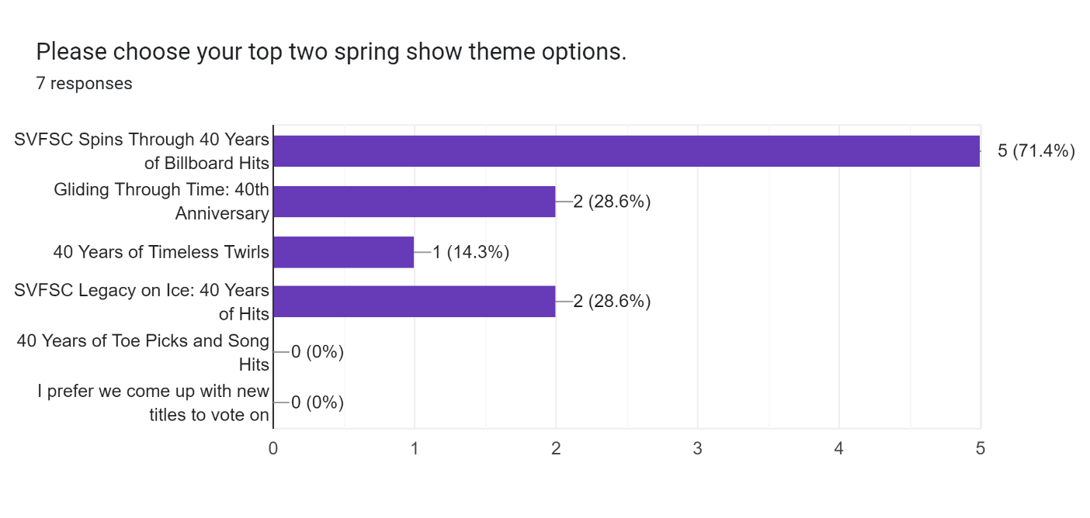

- NDSCS Parade
  - Date is Saturday, Oct. 7 at 10 a.m.
  - Amanda ordered banner – in club room –
Action Item: Amanda will get PVC Pipe for walking with it.
  - We will borrow Rachelle’s pick up – Bethany’s husband Mike will drive
  - Heather to get candy and buckets – buckets are in club room
Action Item: Heather to get Candy
  - Young skaters in pick up bed, older skaters to walk or roller blade

Action Item: Amanda & Heather to coordinate signs & other decor

New Business

- Holiday Exhibition
  - Recommendation to change the Holiday Show to Exhibition as it is more of an opportunity for skaters to show their skills, rather than skate to choreographed numbers like is done for Spring Show.
  - Recommend free-will offering versus $5 entrance fee. Shannon made a motion to have admission be a Free Will Offering of either Cash or Food to then be donated to the Richland Wilkin Food Pantry. Rachelle seconded this. Motion Carried
Action Item: Rachelle to bring totes to put food in.
Action Item: Photo with skaters with the donations.
Action Item: Ginger to set up Volunteer Opportunity on Go Motion for delivering.
  - Time: To allow time to Zam the Ice it was suggested by Kayla to have the Exhibition start a little earlier than in the past. Start time to be 4:30.

- Discount Ice for Future Sessions
- Private Ice Blocks – length of blocks
There was some discussion, about items 2 & 3 above. It was then motioned by Melissa and seconded by Shannon to form and send this to a committee for a report back to the board for the Dec 10th meeting. – Motion Carried. The following have agreed to be on the committee: Kayla, Paula, Ginger, Shannon & Rachelle.

- Committee/Coordinator Reports
  - Fall Kick-off – Heather: all underway. Board members have various tasks throughout the night, if possible please be at the rink between 2-2:30 to help get set up.

  - Camp – Bethany provided an update on projected costs, schedule, levels, etc. The committee was looking for guidance from the board on registration fees.

Fees: Rachelle Made a motion to charge the following, Shannon seconded, motion carried.

 | LTS | Advanced
SVFSC Members | $50 | $100
Outside Club Members | $75 | $125

Approx Costs: $3000 for advanced coaches
$800 for Learn to Skate Coaches
Mileage will be paid at Government Rate
Hotels will be reimbursed.

Action Item: Amanda to work with Rachelle to get room block set up

Size: Camp will be limited to 60 skaters. 30 LTS & 30 Adv

Definition of Classifications for Camp:
LTS – Basic 1 to Free Skate 6
ADV – PrePre Moves in the Field and above
Skaters will need to provide levels for tests passed for both Free Skate & Moves in the Field.

Motion was made by Amanda, 2nd by Andy to allow for additional financial assistance to be applied for to attend the camp, motion failed on a 1 yes 2 no vote.

  - Costume
    - Approve budget for Spring Show costumes – due to increased costs of labor & supplies, Rachelle motioned to increase the per costume budget to $75 per costume for the Spring Show. This was seconded by Shannon, motion carried.
  - Volunteer Coordinator – Melissa
    - Suggestion to increase volunteer credit: Melissa made a motion to increase the payment for additional hours to $10 per hour, to remove the family maximum, changing it to a per skater maximum of $100 earned in volunteer credit. This is to take effect immediately for Fall 23 session. Paula second, motion carried.

Action Item: Ginger to send out updated Volunteer Agreement to those who have already registered for Fall Ice. And update the Volunteer agreement in Go Motion.

Action Item: Compensation Committee needs to meet to clarify who gets the extra $50 credit for their positions held within the club; ie: Coaches, Board Members, Contractors, etc.

  - 40th Anniversary – Shannon. Plans are under way. Kelly Smith is interested and checking his schedule for skating at the show.

Action Item: Shannon to Contact the Daily News. Editor, Sports Editor & Frank. To talk about the events pertaining to our 40th Celebration. Work with Heather for Camp Coverage

  - Safe Skate – Shannon – please check to make sure you are compliant. Shannon has also reached out to those who are not. Can be done by logging into your USFSA account.
  - Financial Assistance – Erica/Melissa - as of the meeting two people had turned in requests for Financial Assistance. The committee will review and complete the process.
    - Forms due Oct. 1
  - Apparel – Heather/Melissa
    - Advanced jackets – Melissa provided a sample jacket, goal is to have these for the first Advanced Comp. Amanda made a motion to allow Melissa & Kayla to finalize the font & colors for the graphic, Rachelle seconded the motion, motion carried.

Action Item: Melissa to bring the adult medium, and the smallest size offered in the jackets to advanced photos. For the girls to try on.
Action Item: Shannon will have a spreadsheet to collect sizes & preferred name for jacket embroidery.
Action Item: Melissa & Kayla to work with Creative Stitches to finalize embroidery.

- Future meeting dates – all times 6:30 p.m.
November 5, 2023
December 10, 2023
January 14, 2024
February 11, 2024 (Super Bowl Sunday, propose Feb. 15? If board is concerned)
March 10, 2024
April 14, 2024
April 28, 2024 General Membership Meeting
June 9, 2024

Adjourn - Amanda Motioned to Adjourn, the meeting at approx. 8:30 – Andy Seconded the motion.

